# CONSOLIDATED EXAM QUESTIONS

# AQUEOUS SOLUTIONS AND ACIDITY

Contents

CONSOLIDATED EXAM QUESTIONS 1

AQUEOUS SOLUTIONS AND ACIDITY 1

Syllabus 2

Properties of Water – 15.1-15.2 3

2017 S2 3

2020 S2 3

2023 S2 3

Solubility (Molecular/Ionic) – 15.3-15.6 4

2017 S2 4

2020 S2 6

2023 S2 6

Precipitation Reactions – 16.1 7

2017 S2 7

2020 S2 7

2023 S2 7

Concentration and Calculations of solutions – 16.2-16.5 8

2017 S2 8

2020 S2 14

2023 S2 14

Acids and Bases – 17.1-17.4 15

2017 S2 15

2020 S2 16

2023 S2 24

# Syllabus

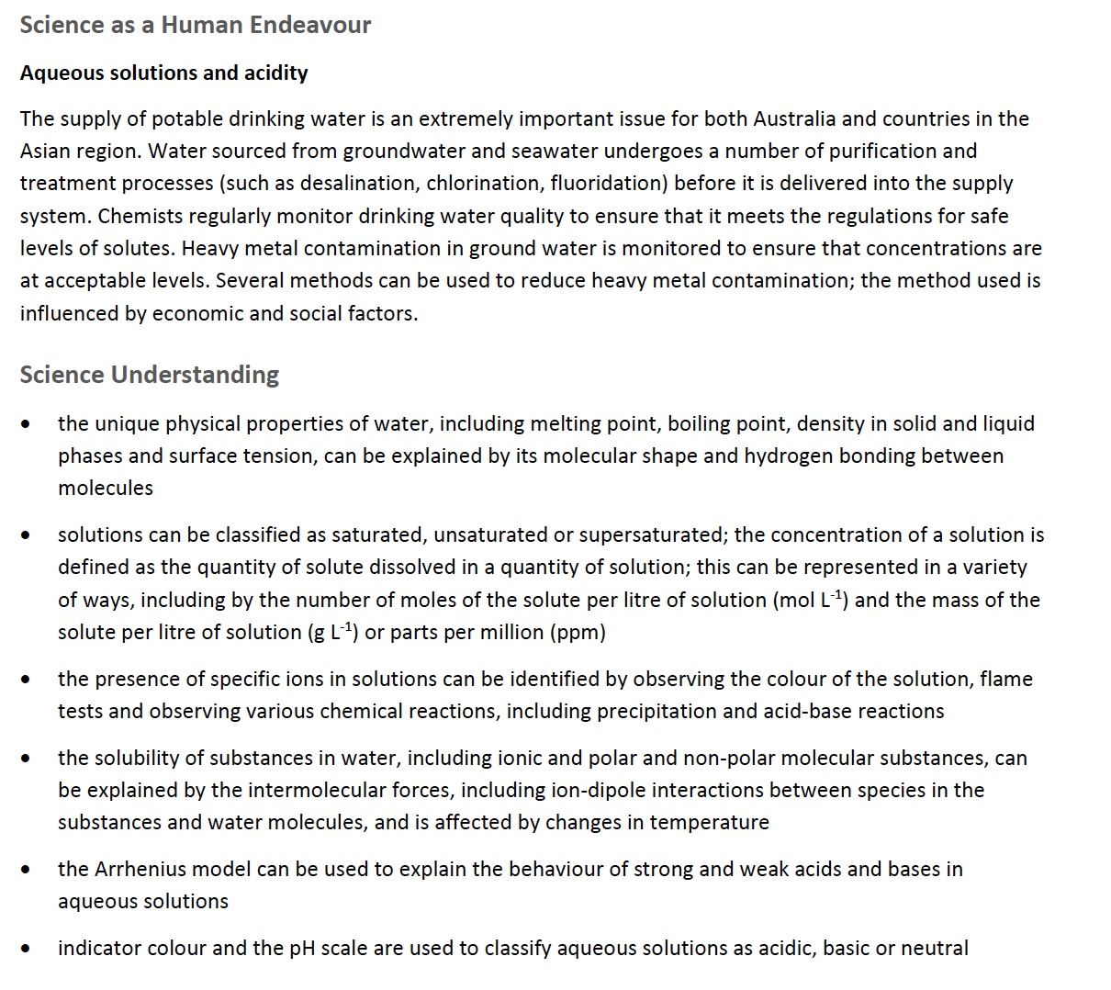

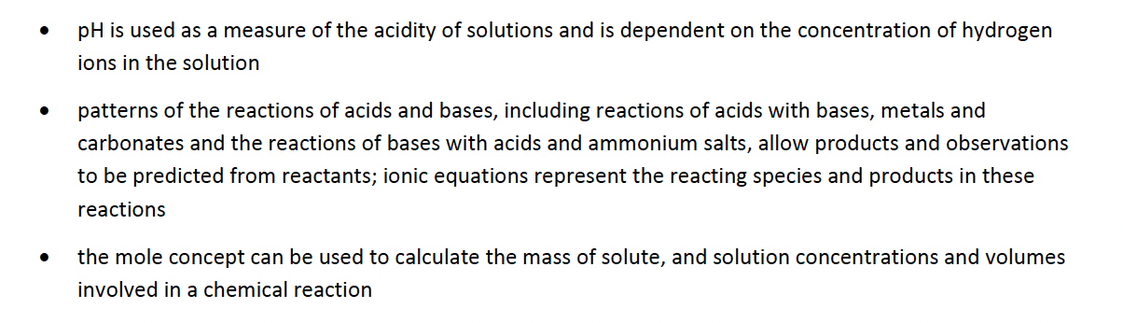

# Properties of Water – 15.1-15.2

## 2017 S2

## 2020 S2

## 2023 S2

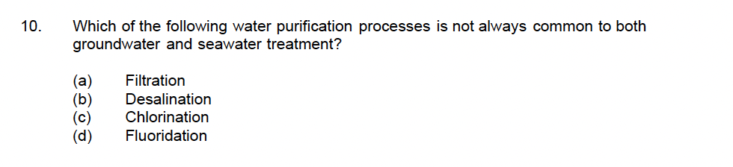

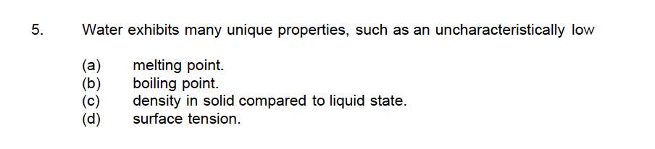

# Solubility (Molecular/Ionic) – 15.3-15.6

## 2017 S2

## 2020 S2

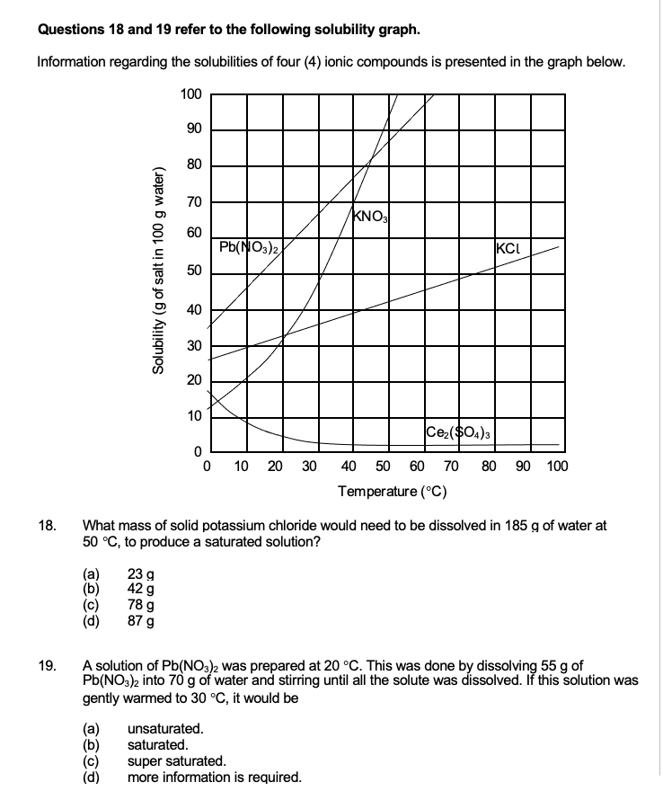

## 2023 S2

# Precipitation Reactions – 16.1

## 2017 S2

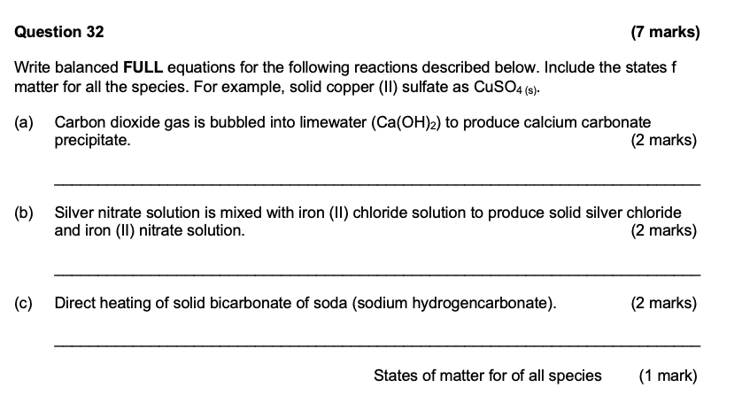

## 2020 S2

## 2023 S2

# Concentration and Calculations of solutions – 16.2-16.5

## 2017 S2

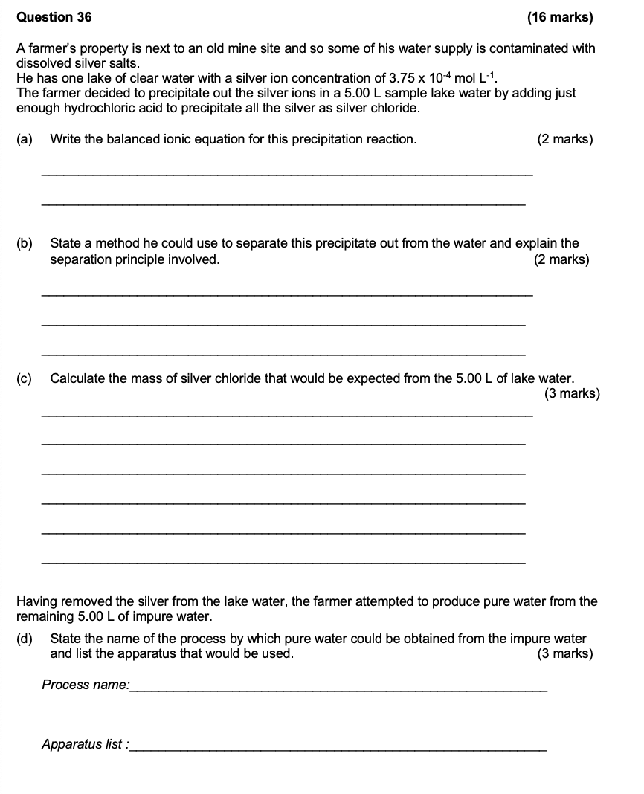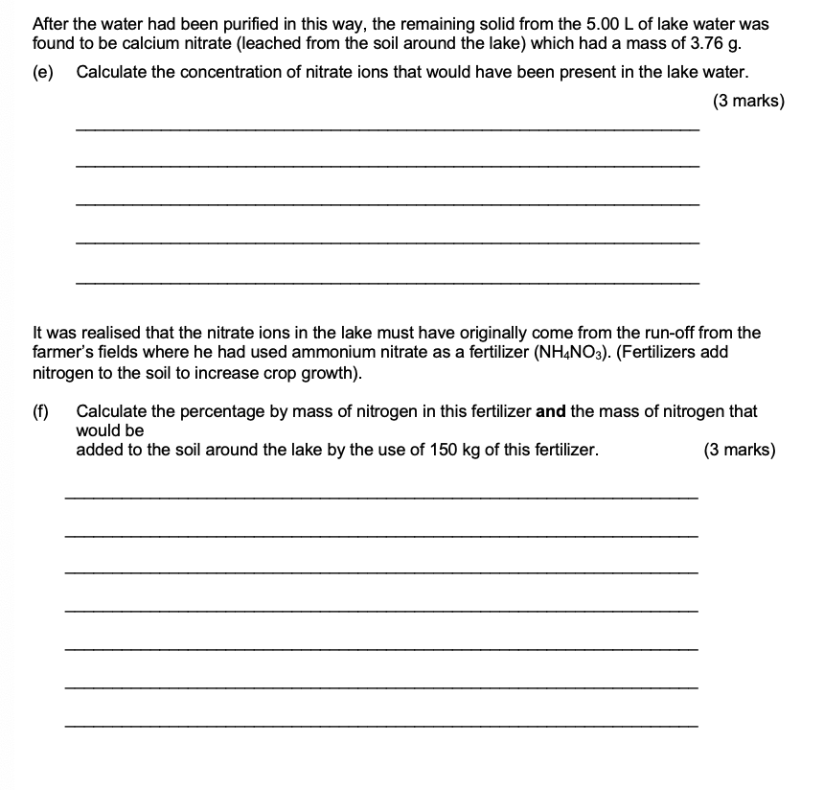

## 2020 S2

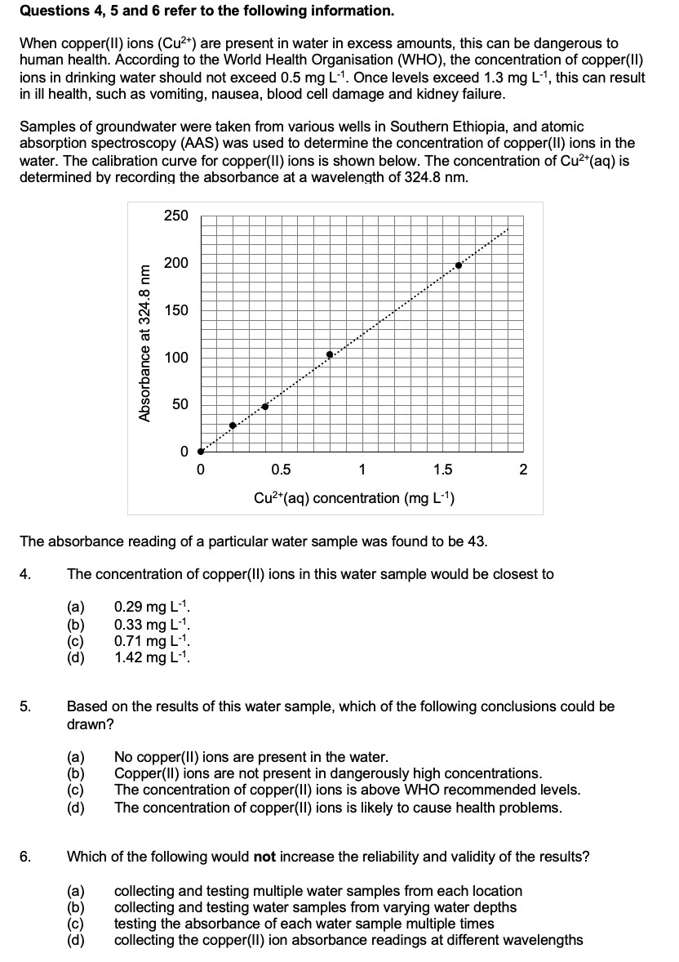

## 2023 S2

# Acids and Bases – 17.1-17.4

## 2017 S2

## 2020 S2

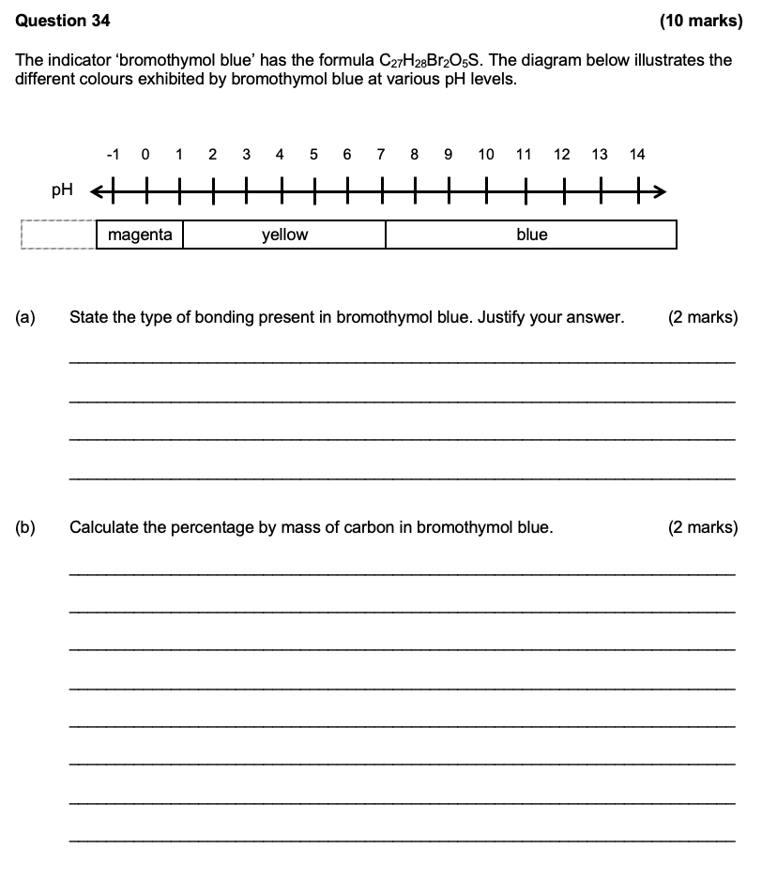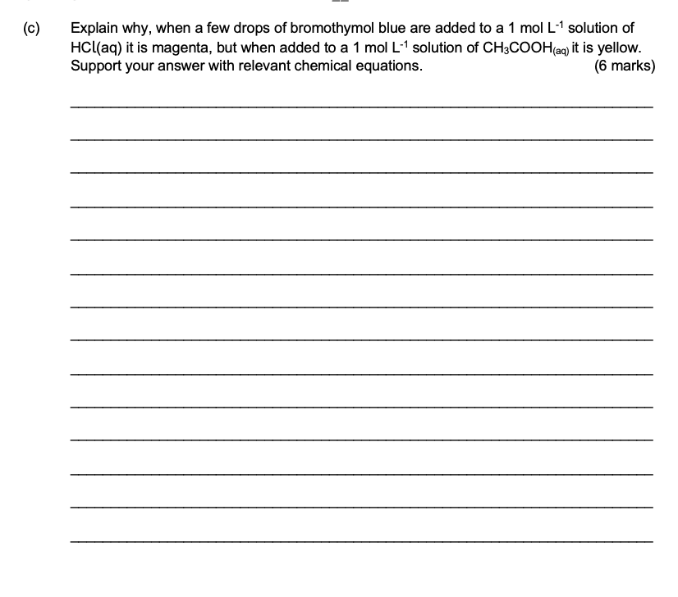

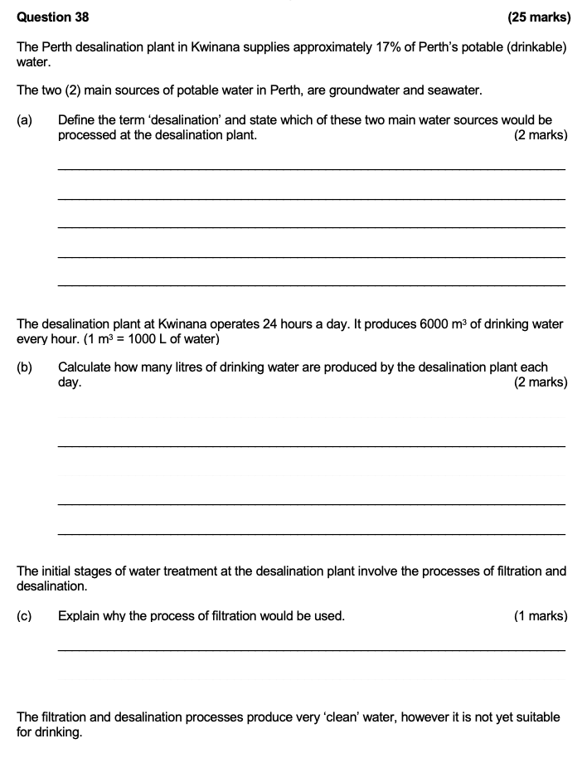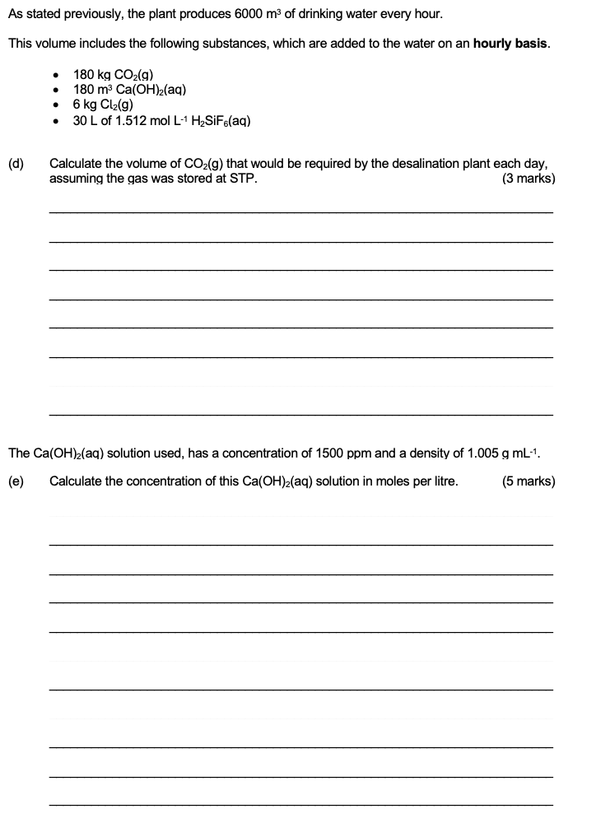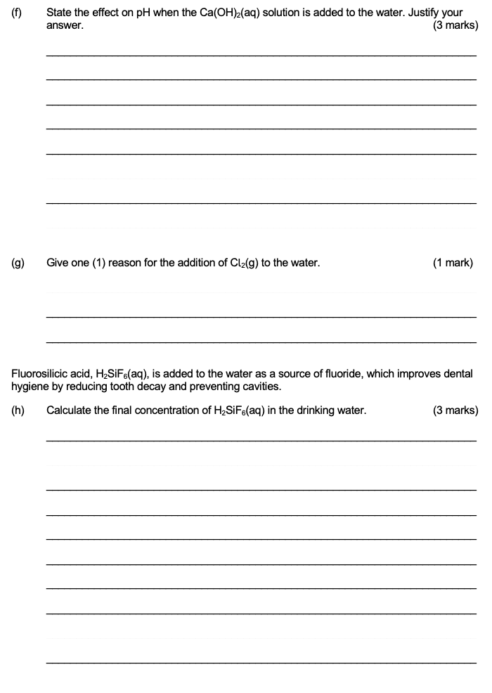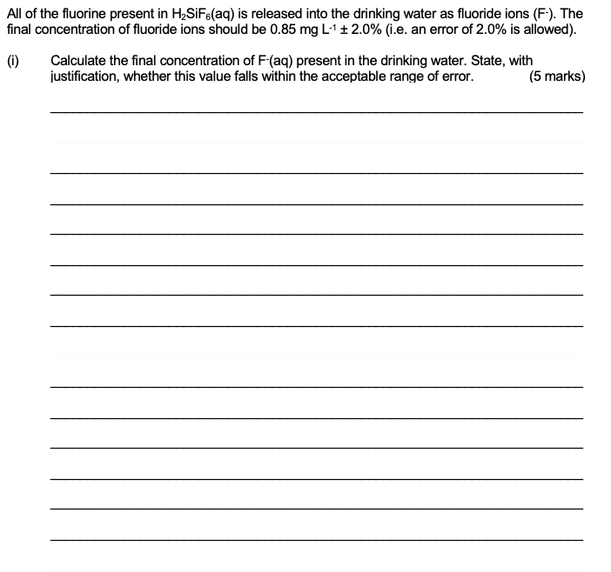

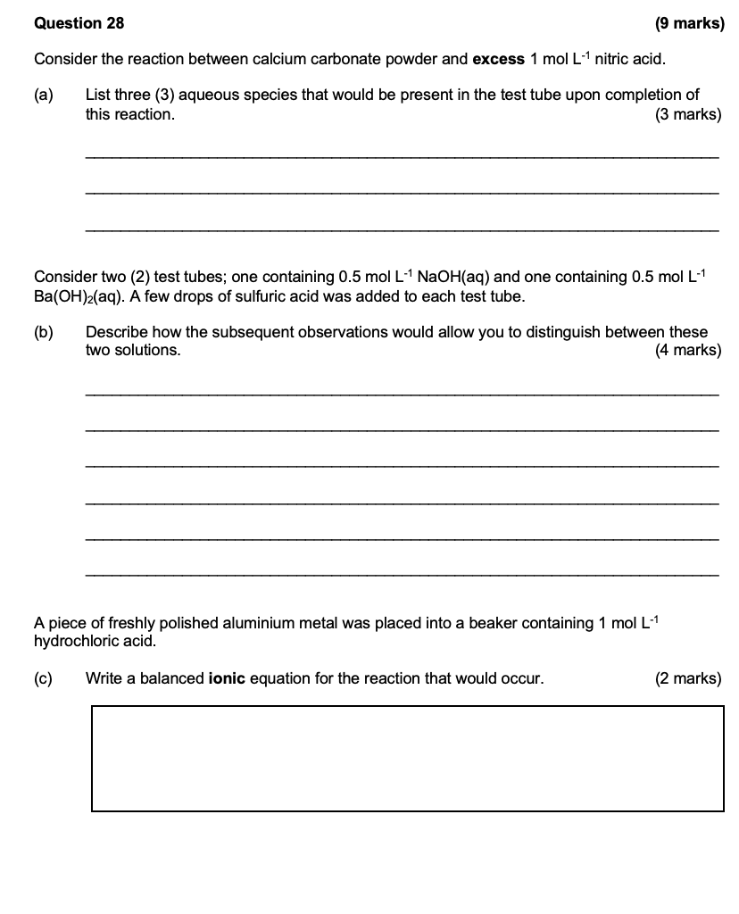

## 2023 S2



